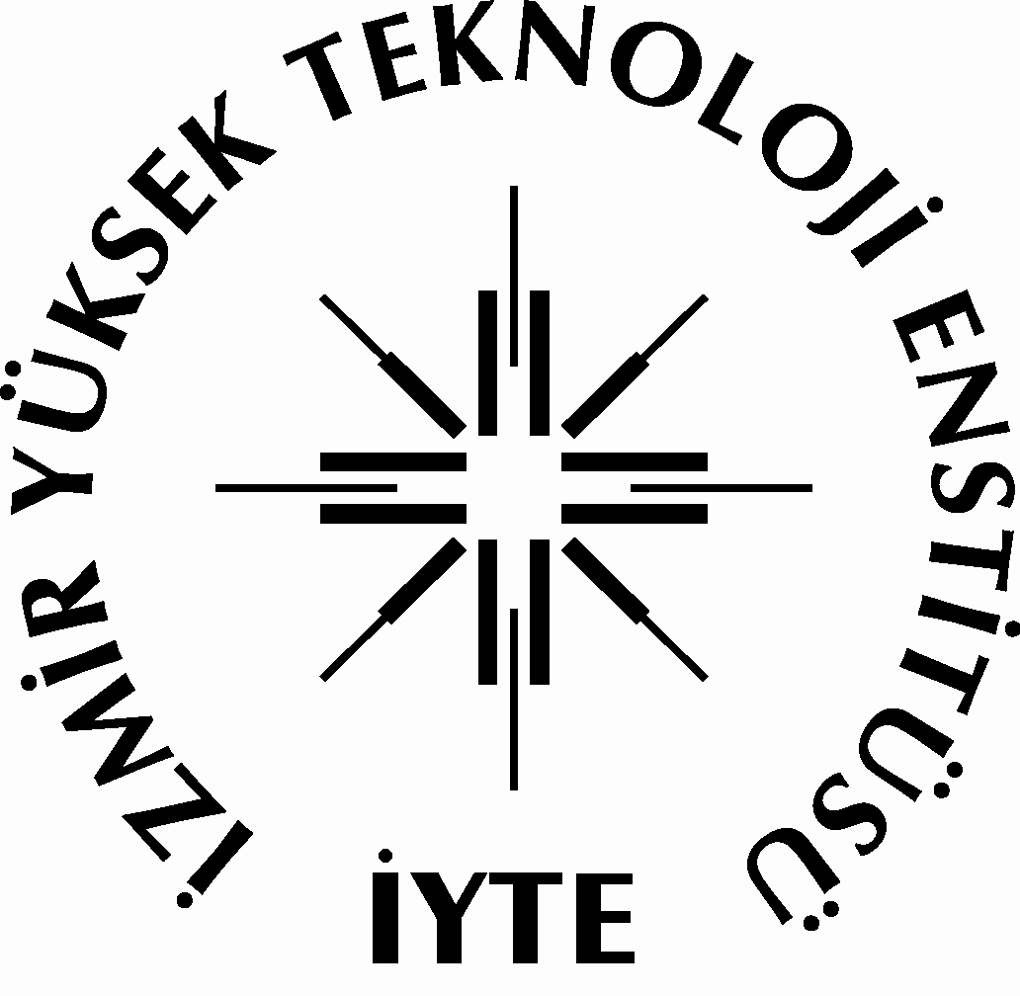 2019-2020 EĞİTİM-ÖĞRETİM YILI BAHAR DÖNEMİ UZAKTAN EĞİTİMLE VERİLEMEYEN TELAFİ DERSLERİ DERS PROGRAMI

BÖLÜM : KİMYA
SINIF : 1
 | PAZARTESİ | SALI | ÇARŞAMBA | PERŞEMBE | CUMA
8.45-9.30 |  | CHEM 132 (K)  General Chemistry Lab II (0+4)2  Doç.Dr. Ü.Hakan YILDIZ  CHEM 132 (MBM)  General Chemistry Lab II (0+4)2  Doç.Dr. Ü.Hakan YILDIZ  CHEM 132 (MBG)  General Chemistry Lab II (0+4)2  Prof.Dr. Durmuş ÖZDEMİR  CHEM 142 (BİYOM)  General Chemistry Lab II (0+2)1  Doç.Dr. Engin KARABUDAK  CHEM 142 (F)  General Chemistry Lab II (0+2)1  Prof.Dr. Hürriyet POLAT  CHEM 142 (GM+ÇM+ESM)  General Chemistry Lab II (0+2)1  Prof.Dr. Işıl SÖZÜER  CHEM 142 (KM+FOT)  General Chemistry Lab II (0+2)1  Prof.Dr. Serdar ÖZÇELİK |  | CHEM 132 (K)  General Chemistry Lab II (0+4)2  Doç.Dr. Ü.Hakan YILDIZ  CHEM 132 (MBM)  General Chemistry Lab II (0+4)2  Doç.Dr. Ü.Hakan YILDIZ  CHEM 132 (MBG)  General Chemistry Lab II (0+4)2  Prof.Dr. Durmuş ÖZDEMİR  CHEM 142 (BİYOM)  General Chemistry Lab II (0+2)1  Doç.Dr. Engin KARABUDAK  CHEM 142 (F)  General Chemistry Lab II (0+2)1  Prof.Dr. Hürriyet POLAT  CHEM 142 (GM+ÇM+ESM)  General Chemistry Lab II (0+2)1  Prof.Dr. Işıl SÖZÜER  CHEM 142 (KM+FOT)  General Chemistry Lab II (0+2)1  Prof.Dr. Serdar ÖZÇELİK
9.45-10.30 |  | CHEM 132 (K)  General Chemistry Lab II (0+4)2  Doç.Dr. Ü.Hakan YILDIZ  CHEM 132 (MBM)  General Chemistry Lab II (0+4)2  Doç.Dr. Ü.Hakan YILDIZ  CHEM 132 (MBG)  General Chemistry Lab II (0+4)2  Prof.Dr. Durmuş ÖZDEMİR  CHEM 142 (BİYOM)  General Chemistry Lab II (0+2)1  Doç.Dr. Engin KARABUDAK  CHEM 142 (F)  General Chemistry Lab II (0+2)1  Prof.Dr. Hürriyet POLAT  CHEM 142 (GM+ÇM+ESM)  General Chemistry Lab II (0+2)1  Prof.Dr. Işıl SÖZÜER  CHEM 142 (KM+FOT)  General Chemistry Lab II (0+2)1  Prof.Dr. Serdar ÖZÇELİK |  | CHEM 132 (K)  General Chemistry Lab II (0+4)2  Doç.Dr. Ü.Hakan YILDIZ  CHEM 132 (MBM)  General Chemistry Lab II (0+4)2  Doç.Dr. Ü.Hakan YILDIZ  CHEM 132 (MBG)  General Chemistry Lab II (0+4)2  Prof.Dr. Durmuş ÖZDEMİR  CHEM 142 (BİYOM)  General Chemistry Lab II (0+2)1  Doç.Dr. Engin KARABUDAK  CHEM 142 (F)  General Chemistry Lab II (0+2)1  Prof.Dr. Hürriyet POLAT  CHEM 142 (GM+ÇM+ESM)  General Chemistry Lab II (0+2)1  Prof.Dr. Işıl SÖZÜER  CHEM 142 (KM+FOT)  General Chemistry Lab II (0+2)1  Prof.Dr. Serdar ÖZÇELİK
10.45-11.30 |  | CHEM 132 (K)  General Chemistry Lab II (0+4)2  Doç.Dr. Ü.Hakan YILDIZ  CHEM 132 (MBM)  General Chemistry Lab II (0+4)2  Doç.Dr. Ü.Hakan YILDIZ  CHEM 132 (MBG)  General Chemistry Lab II (0+4)2  Prof.Dr. Durmuş ÖZDEMİR |  | CHEM 132 (K)  General Chemistry Lab II (0+4)2  Doç.Dr. Ü.Hakan YILDIZ  CHEM 132 (MBM)  General Chemistry Lab II (0+4)2  Doç.Dr. Ü.Hakan YILDIZ  CHEM 132 (MBG)  General Chemistry Lab II (0+4)2  Prof.Dr. Durmuş ÖZDEMİR
11.45-12.30 |  | CHEM 132 (K)  General Chemistry Lab II (0+4)2  Doç.Dr. Ü.Hakan YILDIZ  CHEM 132 (MBM)  General Chemistry Lab II (0+4)2  Doç.Dr. Ü.Hakan YILDIZ  CHEM 132 (MBG)  General Chemistry Lab II (0+4)2  Prof.Dr. Durmuş ÖZDEMİR |  | CHEM 132 (K)  General Chemistry Lab II (0+4)2  Doç.Dr. Ü.Hakan YILDIZ  CHEM 132 (MBM)  General Chemistry Lab II (0+4)2  Doç.Dr. Ü.Hakan YILDIZ  CHEM 132 (MBG)  General Chemistry Lab II (0+4)2  Prof.Dr. Durmuş ÖZDEMİR
13.30-14.15

14.30-15.15

15.30-16.15

16.30-17.15

2019-2020 EĞİTİM-ÖĞRETİM YILI BAHAR DÖNEMİ UZAKTAN EĞİTİMLE VERİLEMEYEN TELAFİ DERSLERİ DERS PROGRAMI

BÖLÜM : KİMYA
SINIF : 2
 | MONDAY | TUESDAY | WEDNESDAY | THURSDAY | FRIDAY
8.45-9.30 |  |  |  |  | CHEM 232 (K)  Analytical Chemistry Lab.II (0+4)2  Prof.Dr.Ahmet E. EROĞLU
9.45-10.30 |  |  |  |  | CHEM 232 (K)  Analytical Chemistry Lab.II (0+4)2  Prof.Dr.Ahmet E. EROĞLU
10.45-11.30 | CHEM 234 (K)  Organic Chemistry Lab.II (0+6)3  Prof.Dr.Levent ARTOK |  |  | CHEM 234 (K)  Organic Chemistry Lab.II (0+6)3  Prof.Dr.Levent ARTOK | CHEM 232 (K)  Analytical Chemistry Lab.II (0+4)2  Prof.Dr.Ahmet E. EROĞLU
11.45-12.30 | CHEM 234 (K)  Organic Chemistry Lab.II (0+6)3  Prof.Dr.Levent ARTOK |  |  | CHEM 234 (K)  Organic Chemistry Lab.II (0+6)3  Prof.Dr.Levent ARTOK | CHEM 232 (K)  Analytical Chemistry Lab.II (0+4)2  Prof.Dr.Ahmet E. EROĞLU
13.30-14.15 | CHEM 234 (K)  Organic Chemistry Lab.II (0+6)3  Prof.Dr.Levent ARTOK |  | CHEM 232 (K)  Analytical Chemistry Lab.II (0+4)2  Prof.Dr.Ahmet E. EROĞLU | CHEM 234 (K)  Organic Chemistry Lab.II (0+6)3  Prof.Dr.Levent ARTOK
14.30-15.15 | CHEM 234 (K)  Organic Chemistry Lab.II (0+6)3  Prof.Dr.Levent ARTOK |  | CHEM 232 (K)  Analytical Chemistry Lab.II (0+4)2  Prof.Dr.Ahmet E. EROĞLU | CHEM 234 (K)  Organic Chemistry Lab.II (0+6)3  Prof.Dr.Levent ARTOK
15.30-16.15 | CHEM 234 (K)  Organic Chemistry Lab.II (0+6)3  Prof.Dr.Levent ARTOK |  | CHEM 232 (K)  Analytical Chemistry Lab.II (0+4)2  Prof.Dr.Ahmet E. EROĞLU | CHEM 234 (K)  Organic Chemistry Lab.II (0+6)3  Prof.Dr.Levent ARTOK
16.30-17.15 | CHEM 234 (K)  Organic Chemistry Lab.II (0+6)3  Prof.Dr.Levent ARTOK |  | CHEM 232 (K)  Analytical Chemistry Lab.II (0+4)2  Prof.Dr.Ahmet E. EROĞLU | CHEM 234 (K)  Organic Chemistry Lab.II (0+6)3  Prof.Dr.Levent ARTOK

2019-2020 EĞİTİM-ÖĞRETİM YILI BAHAR DÖNEMİ UZAKTAN EĞİTİMLE VERİLEMEYEN TELAFİ DERSLERİ DERS PROGRAMI

BÖLÜM : KİMYA
SINIF : 3
 | MONDAY | TUESDAY | WEDNESDAY | THURSDAY | FRIDAY
8.45-9.30 |  |  | CHEM 334 (K)  Physical Chemistry Lab.II (0+4)2  Prof.Dr.Talat YALÇIN |  | CHEM 332 (K)  Inorganic Chemistry Lab. (0+4)2  Prof.Dr.Mehtap EANES
9.45-10.30 |  |  | CHEM 334 (K)  Physical Chemistry Lab.II (0+4)2  Prof.Dr.Talat YALÇIN |  | CHEM 332 (K)  Inorganic Chemistry Lab. (0+4)2  Prof.Dr.Mehtap EANES
10.45-11.30 |  |  | CHEM 334 (K)  Physical Chemistry Lab.II (0+4)2  Prof.Dr.Talat YALÇIN |  | CHEM 332 (K)  Inorganic Chemistry Lab. (0+4)2  Prof.Dr.Mehtap EANES
11.45-12.30 |  |  | CHEM 334 (K)  Physical Chemistry Lab.II (0+4)2  Prof.Dr.Talat YALÇIN |  | CHEM 332 (K)  Inorganic Chemistry Lab. (0+4)2  Prof.Dr.Mehtap EANES
13.30-14.15 |  | CHEM 332 (K)  Inorganic Chemistry Lab. (0+4)2  Prof.Dr.Mehtap EANES | CHEM 332 (K)  Inorganic Chemistry Lab. (0+4)2  Prof.Dr.Mehtap EANES |  | CHEM 334 (K)  Physical Chemistry Lab.II (0+4)2  Prof.Dr.Talat YALÇIN
14.30-15.15 |  | CHEM 332 (K)  Inorganic Chemistry Lab. (0+4)2  Prof.Dr.Mehtap EANES | CHEM 332 (K)  Inorganic Chemistry Lab. (0+4)2  Prof.Dr.Mehtap EANES |  | CHEM 334 (K)  Physical Chemistry Lab.II (0+4)2  Prof.Dr.Talat YALÇIN
15.30-16.15 |  | CHEM 332 (K)  Inorganic Chemistry Lab. (0+4)2  Prof.Dr.Mehtap EANES | CHEM 332 (K)  Inorganic Chemistry Lab. (0+4)2  Prof.Dr.Mehtap EANES |  | CHEM 334 (K)  Physical Chemistry Lab.II (0+4)2  Prof.Dr.Talat YALÇIN
16.30-17.15 |  | CHEM 332 (K)  Inorganic Chemistry Lab. (0+4)2  Prof.Dr.Mehtap EANES | CHEM 332 (K)  Inorganic Chemistry Lab. (0+4)2  Prof.Dr.Mehtap EANES |  | CHEM 334 (K)  Physical Chemistry Lab.II (0+4)2  Prof.Dr.Talat YALÇIN
2019-2020 EĞİTİM-ÖĞRETİM YILI BAHAR DÖNEMİ UZAKTAN EĞİTİMLE VERİLEMEYEN TELAFİ DERSLERİ DERS PROGRAMI

BÖLÜM : KİMYA
SINIF : 4
 | MONDAY | TUESDAY | WEDNESDAY | THURSDAY | FRIDAY
8.45-9.30 |  |  |  | CHEM 499  Cooperative Education Course (0+6)3  Prof.Dr.Durmuş ÖZDEMİR | CHEM 499  Cooperative Education Course (0+6)3  Prof.Dr.Durmuş ÖZDEMİR
9.45-10.30 |  | CHEM 402  Graduation Project II(0+6)3  Prof.Dr. Ali ÇAĞIR |  | CHEM 499  Cooperative Education Course (0+6)3  Prof.Dr.Durmuş ÖZDEMİR | CHEM 499  Cooperative Education Course (0+6)3  Prof.Dr.Durmuş ÖZDEMİR
10.45-11.30 |  | CHEM 402  Graduation Project II(0+6)3  Prof.Dr. Ali ÇAĞIR | CHEM 402  Graduation Project II(0+6)3  Prof.Dr. Ali ÇAĞIR | CHEM 402  Graduation Project II(0+6)3  Prof.Dr. Talat YALÇIN | CHEM 499  Cooperative Education Course (0+6)3  Prof.Dr.Durmuş ÖZDEMİR
11.45-12.30 |  |  | CHEM 402  Graduation Project II(0+6)3  Prof.Dr. Ali ÇAĞIR | CHEM 402  Graduation Project II(0+6)3  Prof.Dr. Talat YALÇIN | CHEM 499  Cooperative Education Course (0+6)3  Prof.Dr.Durmuş ÖZDEMİR
13.30-14.15 |  |  |  | CHEM 402  Graduation Project II(0+6)3  Prof.Dr. Talat YALÇIN | CHEM 402  Graduation Project II(0+6)3  Prof.Dr. Ahmet E. EROĞLU  CHEM 402  Graduation Project II(0+6)3  Prof.Dr. Ali ÇAĞIR  CHEM 402  Graduation Project II(0+6)3  Doç.Dr. Ü. Hakan YILDIZ
14.30-15.15 |  |  |  | CHEM 402  Graduation Project II(0+6)3  Prof.Dr. Talat YALÇIN  CHEM 402  Graduation Project II(0+6)3  Doç.Dr. Mustafa EMRULLAHOĞLU | CHEM 402  Graduation Project II(0+6)3  Prof.Dr. Ahmet E. EROĞLU  CHEM 402  Graduation Project II(0+6)3  Prof.Dr. Ali ÇAĞIR  CHEM 402  Graduation Project II(0+6)3  Doç.Dr. Ü. Hakan YILDIZ  CHEM 402  Graduation Project II(0+6)3  Doç.Dr. Mustafa EMRULLAHOĞLU
15.30-16.15 |  |  | CHEM 402  Graduation Project II(0+6)3  Doç.Dr. Ü. Hakan YILDIZ | CHEM 402  Graduation Project II(0+6)3  Prof.Dr. Ahmet E. EROĞLU  CHEM 402  Graduation Project II(0+6)3  Doç.Dr. Ü. Hakan YILDIZ  CHEM 402  Graduation Project II(0+6)3  Prof.Dr. Talat YALÇIN  CHEM 402  Graduation Project II(0+6)3  Doç.Dr. Mustafa EMRULLAHOĞLU | CHEM 402  Graduation Project II(0+6)3  Prof.Dr. Ahmet E. EROĞLU  CHEM 402  Graduation Project II(0+6)3  Doç.Dr. Mustafa EMRULLAHOĞLU
16.30-17.15 |  |  | CHEM 402  Graduation Project II(0+6)3  Doç.Dr. Ü. Hakan YILDIZ | CHEM 402  Graduation Project II(0+6)3  Prof.Dr. Ahmet E. EROĞLU  CHEM 402  Graduation Project II(0+6)3  Doç.Dr. Ü. Hakan YILDIZ  CHEM 402  Graduation Project II(0+6)3  Prof.Dr. Talat YALÇIN  CHEM 402  Graduation Project II(0+6)3  Doç.Dr. Mustafa EMRULLAHOĞLU | CHEM 402  Graduation Project II(0+6)3  Prof.Dr. Ahmet E. EROĞLU  CHEM 402  Graduation Project II(0+6)3  Doç.Dr. Mustafa EMRULLAHOĞLU

